H38b
USCIS REFERRAL
Community Service Providers
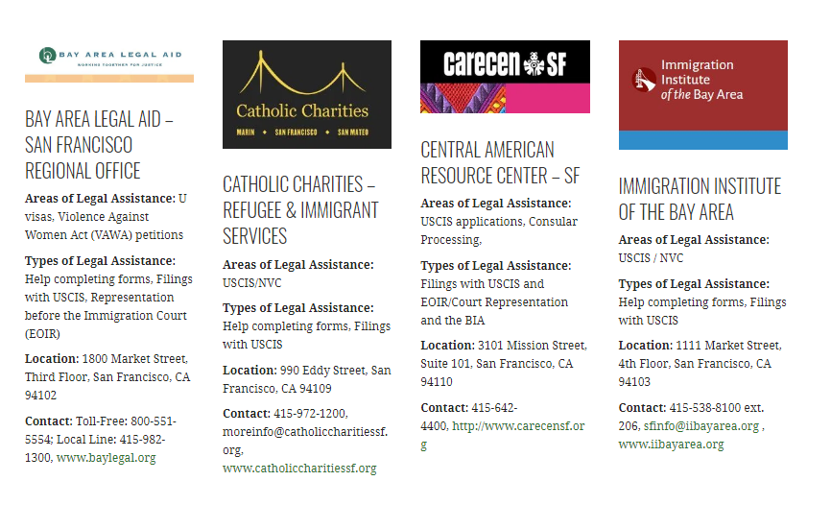
Immigration Attorneys
